Double-click on the field labeled Layer 1 and rename it Triangle.
Click on frame 20 to select it, and then choose Frame from the Insert menu.
All the frames except the first are blank.
Select the sixth frame. Choose Insert, then Keyframe.
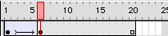
Timeline with two Keyframes and Tweening
Let's make the animation better. To do this, you must make a symbol.
Choose Window and then Library to access the Library for this movie.
Click on the first frame in the Timeline and then select the triangle you drew. Choose Insert, then Convert to Symbol. Name the new symbol Triangle and select Graphic as its Behavior.
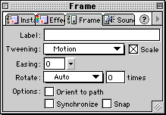
Applying tweening in the Frame panel
Click on the sixth frame or the second Keyframe. The presymbol triangle should still be sitting there. Delete it, then select the triangle on the Library palette. Drag the preview of the symbol into the Stage area to a location close to the object you just deleted. Now select any frame between the two Keyframes. Look for the Frame panel. If you can't find it, select Window:Panels:Frame once or twice until it comes forward. From the tweening pulldown, select Motion. Leave everything else at its default setting and click OK. Now you'll notice an arrow in the Timeline that indicates the tweening.
Hit the Enter key and marvel at the improvements to your animation. And it's only going to get better.

